BMA House
Tavistock Square
London WC1H 9JP

Jo Churchill MP
Parliamentary Under Secretary of State (Minister for Prevention, Public Health and Primary Care)
Department of Health and Social Care
39 Victoria Street
London, SW1H 0EU

Sent by email

13 January 2021

Dear Parliamentary Under Secretary of State,

Re: Failure of PPE in meeting the diverse needs of the medical workforce – sustained reports of female doctors struggling to find respirator masks that pass fit testing

I am writing to highlight persistent concerns from BMA members regarding inadequacy of appropriate PPE provision for healthcare workers – specifically, ill-fitting PPE unsuitable for the wearer. I am sure you will understand that these concerns have only been heightened by the identification of the new COVID-19 variant (designated VOC-202012/01) and the recent, alarming increases in transmission. I am requesting that the appropriate PPE is made available, urgently, to meet the diverse needs of the healthcare workforce.

NHS staff have been unwavering in their professionalism and dedication to protecting the health and wellbeing of their patients. In turn, no doctor’s safety should be compromised by a lack of suitable PPE. Guidance and provision must take account of differing needs of the individual healthcare worker; no matter who you are, you should have proper-fitting PPE – regardless of gender, ethnicity and religion.

However, our members continue to report issues. Female doctors are still struggling to find masks that fit, often failing the ‘fit test’ or being left with sores and ulcers after long shifts when wearing masks that did not fit. We have raised concerns in the past that PPE is designed to fit men, even though 75% of the NHS workforce are women.

Without properly fitting face protection, these staff are putting themselves at risk. Respiratory protective equipment must be properly fitting, in line with HSE guidance, and the provision of alternative PPE (such as hoods) should be made available, as necessary. A one-size-fits-all attitude is not appropriate: all staff, in all settings, must be equitably protected with suitable and sufficient PPE. I urge you to address this matter without delay and would be happy to discuss this in more detail with you.

Please note that the BMA has written separately to PHE to request that a more precautionary approach is adopted to the provision of respiratory protective equipment. We believe this is necessary to better protect staff from aerosol transmission. A copy of that letter is attached for your reference.
Yours sincerely,
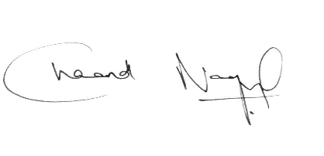

Dr Chaand Nagpaul CBE
BMA council chair

cc. Michael Brodie, Interim Chief Executive, PHE

